SPECIAL THANKS TO:

Our greatest thanks to Betty Lin for her outstanding and valuable contribution to making this program a success

AISG Students

Parents of the AISG Students

AISG Teachers

Ben Leong - AISG Music Teaching Assistant

Si Hu for his Technical Assistance

Eve Huang - AISG Accountant

Gloria Xinyue Huang – AISG Student Assistant

AISG Tech Team
Ken Liu
Wen Wei Zheng

Alan Henry - Social Media Manager - BroadwayWorld.com

Ted Sterns – Passport to Broadway Lighting Designer

Victoria Navarro – StudentsLive Intern

Special Thanks to the AISG Administration and Faculty for their support.

Thanks to the Development and Communications Office for their help in promoting this event.

Thanks to all AISG support Staff especially Faye Huang and her team for helping with catering, busing, and facility management.

Thanks to Wen Wei Zheng and his tech team for theater management.

Thanks to Eva Ho and her team for purchasing big things and small.

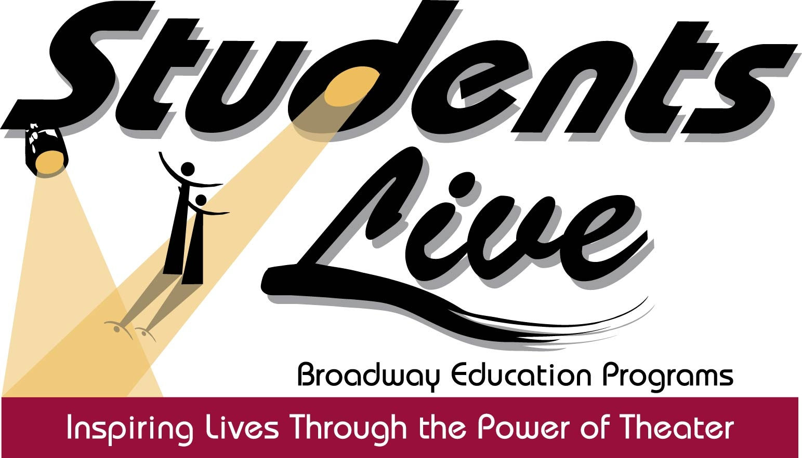
PRESENTS
AISG PASSPORT TO BROADWAY MUSICAL THEATRE INTENSIVE
SUMMER 2017
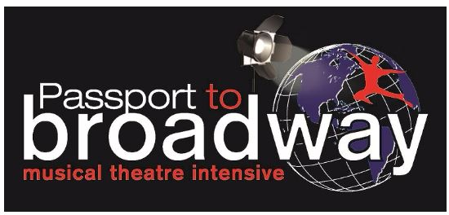
FEATURING
Students of the American International School of Guangzhou
SUNDAY JUNE 25, 2017 AT 4:00PM
AISG SCIENCE PARK CAMPUS
GUANGZHOU, CHINA
“ONE MOMENT”

STARRING: Grace Cao, Manogya Chandar, Samyutha Chander, Chih-Hsuan Chang, Sara Chen, Zoe Cheng, Jasmine Li, Jenny Xiyan Liang, Beatrice Mai, Isaac Nie, Brennan Parker, Sabina Pihowich, Abraham Qian, Alex Qian, Annabelle Qian, Santiago Villar, Susan Xu Rui Wang, Emma Wong, Ki Ki Wu, Fi Fi Xu , Fiona Xu, Jessalyn Yara Yang, Ziyue Yang, Youzhang Zeng, Charis Zhang, Cheryl Zhang, Rachel Zhang, Richard Zhang, Joey Zhu, Michelle Zhuang

Letter from Amy Weinstein, Director and CEO StudentsLive/Passport to Broadway

Dear Community Members, Staff, Students, Faculty, Friends and Supporters of AISG,

These last two weeks have been a powerful experience for me and my creative and production team direct from Broadway in New York City. The thirty students involved in this rigorous process grew beyond our wildest imagination with a passion and dedication for learning and performing this very challenging art form in an almost impossible short window of time; What would normally require a Broadway professional at least 6 to 8 weeks of rehearsals was taught and learned eloquently in 10 short days with these exceptional students. They made the virtually impossible, possible. That is a testament to both their talents and hard work, as well as the collaboration and individual expression “Musical Theater” evokes.

I and my Broadway team began working with the incomparable and indefatigable Betty Lin back in 2016, to communicate what a unique challenge this process would be for the students of AISG and why we felt this was important. While you have a stellar Music, Arts and Theater Program, led by very talented faculty, what StudentsLive was planning to bring to your school was a uniquely customized "Broadway Show” designed exclusively for AISG, with the widest range of Broadway material put together in a unique story that reflects the lives, wishes, hopes and dreams of the students here at AISG. Thirty Broadway classical and contemporary musicals were chosen and arranged to incorporate original Broadway staging, choreography and lyrics, adapted into this singular story.

This is a love story between the characters of Kim and Peter, but also a reflection of the hopes and dreams of students who both wish to travel to faraway places (like New York) and those with the opposite desire to stay close to home and

PASSPORT TO BROADWAY PROGRAM TESTIMONIALS

“Nothing will do more to open doors for our young people and prepare them for unimagined new careers.” -Former President Bill Clinton on the StudentsLive Broadway Education Programs

“Programs like these enable a new generation of audiences
to make the arts a permanent part of their lives.” –Former Secretary of State Hillary Clinton on the StudentsLive Broadway Education Programs

“This was the most well-prepared and well-executed education program I have
ever attended…here’s a program that makes students live and breathe in a way
they never did before.” -Peter Filichia, Theatre Critic, Newark Star Ledger and TheaterMania.com

“Wow! I cried though the first 5 numbers and three more times throughout the course of the show. What you put together is incredible. It reminded me of the magic of Broadway and how lucky we all are to be a part of this. More importantly what it can do for these children, how it can bring them out of their shells. You did a wonderful job. I was honored to be a guest.” - Stephanie Klemons, Broadway Cast Member, Hamilton
“The students performed the piece seamlessly. This program should become an integral part of all students United Nations Conference.” -Yvonne Acosta, Chief Education Outreach, The United Nations
“StudentsLive has facilitated a unique, living program that embodies commitment and passion to sharing of theater to children, of the international community, that's both priceless and bold. They're a shining tower for all to look upon and admire.” -Gelan Lambert, Broadway Actor, Fela!
Contact StudentsLive (001) (212) 220-6000
info@studentslive.net
Website: www.studentslive.net www.passporttobroadway.com
Facebook: “StudentsLive Broadway Education Programs”
Twitter: StudentsLiveBEP and PassporttoBroadway
Instagram: studentslive_bep
YouTube: http://www.youtube.com/watch?v=4Iwv737-A8


CREATIVE TEAM:
Produced and Directed by Amy Weinstein who has been developing, creating, marketing and producing education programs in partnership with some of the finest Broadway Artists and Creative teams since 1998. Graduating from New York University with a degree in theater and communication, she began her work early on as a theatrical talent agent and casting director in Hollywood. Due to her expertise, she was asked to teach acting to at-risk teenagers with, The Academy of Performing and Visual Arts in East Los Angeles. Out of her work with these young people, she co-wrote and directed a musical play entitled Second Chance, which toured as an Equity TYA contract to over 350,000 students in California and surrounding states. Ms. Weinstein continued her work in the New York area as an improvisation and acting teacher at the American Musical and Dramatic Academy. She was soon after hired as education director by Tony Randall's Not-For-Profit Broadway Tony Award Nominated National Actors Theater. She currently works as a writer, director and producer both On and Off-Broadway and created StudentsLive Inc.

Jessica James Fraser (Production Supervisor) is happy to continue her lifelong love of theatre with this great program. Having worked with children and youth groups around the country Jessica has witnessed first-hand the power of theatre in the lives of all persons. After attending American University in Washington, DC, Jessica returned home to New York eager to be a part of live theatre. She has worked in sales and marketing on the business side of Broadway and had the privilege of witnessing truly amazing performances on the Broadway stage. Her love for education and bringing live theatre to new audiences drew her to this position with StudentsLive. Jessica is proud to be part of a team doing such wonderful work - educating children and young adults in the language, understanding and appreciation of theatre - an education that will hopefully continue throughout their lives.

Jeff Moulton (Choreographer/Assistant Director) has been working professionally in the arts for more than a decade, performing on stages and screens across the US and his native Canada. Jeff started dance captaining early in his career and has gone on to assistant choreograph and choreograph stage musicals, workshops, and special events.
His work behind the table was further facilitated by assisting Disney Creative Casting in New York City with auditions for their theme parks, cruise ships, and Broadway Guest Artists. He has assistant directed on regional musicals and commercial works in NYC – most recently assisting a Tony Nominated director on the production lab of Romy and Michele’s High School Reunion: The Musical. The new musical he Assistant Directed last year at the Atlantic Theater in Manhattan was named a New York Times’ Critic’s Pick and went on to win the Off-Broadway Alliance Award for Best New Musical.

Seth Weinstein (Musical Director) was the musical director and composer of the Off-Broadway musical How to Save the World and Find True Love in 90 Minutes (New World Stages, 2006). He has toured internationally with Fosse and Ivan Jacobs’s The Phantom of the Opera and in the USA with Almost Heaven: Songs of John Denver. Regionally, he has been the musical director of Black House (Zagreb, Croatia), Do I Hear a Waltz? (Arvada Center), Smokey Joe’s Cafe (Connecticut Repertory Theatre), and Chick Flick (Loft 227 and Millbrook Playhouse), among other shows.
Seth also wrote and recorded “The Chagall Suite” (an eight-movement piano piece based on themes of Marc Chagall’s artworks) and “Conversations” (a musical meeting between Chagall and Elvis Presley), and he has played the pieces in France, Germany, and the USA. He performs monthly with L’Opera Burlesque and he is the pianist for the MAC and Bistro Award–winning Screen Gems: Songs of Old Hollywood (featuring Sarah Rice) and Operation Opera (baritone Adelmo Guidarelli’s amusing tribute to opera, a participant in the 2011 Edinburgh Festival Fringe).

cherish what is in their own backyards. The story takes us into the future, told by Kim as a narrator looking back at her past, who became a successful author in New York City, but had to leave behind the one person she loves, Peter, to pursue her dreams of success.

The story takes us back and forth between past, present and future, told only through music, dance and acting, from the points of view of both perspectives, the universal sacrifices we make for love and/or career, and the everyday lives of young people living in Guangzhou going about their normal business of being students, sons, daughters and friends.

It ends with a celebration of both perspectives, and a resolution that reflects how we are all “ready” for what the future holds and why we are more alike than not, despite the differences in our own individual life journeys and choices.

During our six month preparation for this exciting journey, we selected some of the widest and most challenging range of Broadway material, in order for your children to have access to and be exposed to the greatest opportunity for growth and to experience a true sense of confidence and accomplishment.

Our greatest wish is that this experience will inspire them to continue to take risks, to meet challenges with joy and confidence and pursue their own unique dreams and goals.

With that said, it is my pleasure to be part of this very special community for even this short period of time, and to have helped share some of the joy and love that we have for Broadway Musical Theater with your children.

Thank you, Betty, for allowing us the opportunity to be a part of your very special school. Thank you, parents, for lending us the hearts, talent and courage of your children for this exceptional experience. We hope to see you and the students on Broadway someday, and to return to AISG in the very near future to help inspire even more lives through the power of theater.

Warmest regards,

Amy Weinstein
Artistic Director StudentsLive/Passport to Broadway

PASSPORT TO BROADWAY/STUDENTSLIVE PROFILE
The StudentsLive Passport to Broadway Program (www.passporttobroadway.com) allows students the opportunity to experience, first hand, the best live, Broadway interactive theater education programs, taught by the best, highly trained Broadway specialists, our country has to offer. The program allows students to experience the intensive training of a professional, successful and highly disciplined Broadway Artist and the myriad skills required in collaboration, interrelation, communication and human exploration. The goals are to expand and deepen students understanding and familiarity with all areas of Broadway Theater and to enhance their studies in human behavior, culture, intention and expression. Through challenging music, dance, acting and, most importantly, the unique art form of “putting it all together”, taught by the best professionals on Broadway, StudentsLive prepares students to be highly competitive in whatever career they choose to pursue as well as prepare for the best universities and career opportunities possible.

What happens as a result is a "full-immersion," comprehensive Broadway experience - which starts with simulated Broadway auditions with real casting directors, continues with daily rehearsals that include vocal, acting, and dance coaching, includes meetings and discussions with working Broadway professionals, supplemented by theoretical studies of Broadway musical theater history, and ends with the students finally performing the production that they have been working on for the past two weeks.

Since 2000, StudentsLive’s Award-Winning live interactive education programming have attracted over 100,000 participants from as far away as Guam, The UK, Italy, Brazil, China, South Korea and from all across the United States. The League of American Theatres and Producers and Theatre Development Fund have awarded StudentsLive grants six years in a row for Outstanding Education Programs on Broadway. StudentsLive’s programs are now attracting adult groups and tour internationally in collaboration with presenters all across the world.

Guest Speakers and workshop participants at our high profile Exclusive Student Matinees and Workshops on Broadway have included:
Judge Judy Geraldine Ferraro Johnnie Cochran Tommy Hilfiger
Kathy Lee Gifford Susan Lucci George Hamilton Reba McEntire
Chazz Palminteri Bernadette Peters Joey Fatone Mel B “Scary Spice”

StudentsLive’s programs have been recognized as vital to New York City’s arts and education initiatives by Mayors Michael Bloomberg and Rudolph Giuliani, and have received letters of support and praise from Former President Bill Clinton and Secretary of State Hilary Clinton.

Our programs have also been covered and written about in national and local print and electronic media by The New York Times, The Jane Pauley Show, Court TV, Variety, The Daily News, The New York Post, ABC, CBS, NBC, Fox, UPN, and NY1.
Current and past partnership shows include Wicked and Fela: The Musical. StudentsLive supports alternative learning and cross cultural and interdisciplinary opportunities for all ages.
.MUSICAL NUMBERS:

Act I
"The New World" from SONGS FOR A NEW WORLD, Music and Lyrics by Jason Robert Brown
"Corner of the Sky" from PIPPIN, Music and Lyrics by Stephen Shwartz
“Easy as Life” from AIDA, Music by Elton John, Lyrics by Tim Rice
“Save the People” from GODSPELL, Music and Lyrics by Stephen Schwartz
“Heart and Music” from A NEW BRAIN, Music and Lyrics by William Flinn
“Razzle Dazzle” from CHICAGO, Music by John Kander, Lyrics by Fred Ebb
“We Open Up the Gateways” from KRISTINA, Music by Benny Andersson and Lyrics by Björn Ulvaeus
“Someone Else’s Story” from CHESS, Music by: Benny Andersson and Björn Ulvaeus, Lyrics by: Tim Rice
“Facade” from JEKYLL & HYDE, Music and Lyrics by Frank Wildhorn and Leslie Bricusse

Act II
“Thirteen” from 13 THE MUSCAL, Music and Lyrics by Jason Robert Brown
“Revolting Children” from MATILDA, Music and Lyrics by Tim Minchin
“Believe in Yourself” from THE WIZ, Music by Galt MacDermot, Lyrics by James Rado
“Spoonful of Sugar” from MARY POPPINS, Music and Lyrics by Richard M. Sherman and Robert B. Sherman
“My Favorite Things” from THE SOUND OF MUSIC, Music by Richard Rodgers, Lyrics by Oscar Hammerstein II
“Oh The Thinks You Can Think” from SEUSSICAL, Music by: Stephen Flaherty, Lyrics by: Lynn Ahrens
“Supercalifragilisticexpialidocious” from MARY POPPINS, Music and Lyrics by Richard M. Sherman and Robert B. Sherman
“On My Own” from LES MISERABLES, Music by Claude-Michel Schonberg, Lyrics by Herbert Kretmer and Alain Boublil
“Who Can I Turn To” from THE ROAR OF THE GREASEPAINT THE SMELL OF THE CROWD, Music and Lyrics by Leslie Bricusse and Anthony Newley
“Time Heals Everything” from MACK & MABEL, Music and Lyrics by Jerry Herman
“A Fine, Fine Line” from AVENUE Q, Music and Lyrics by Robert Lopez & Jeff Marx
“I Dreamed a Dream” from LES MISERABLES, Music by Claude-Michel Schonberg, Lyrics by Herbert Kretmer and Alain Boublil
“Money” from CABARET, Music by John Kander, Lyrics by Fred Ebb
“All About the Green” from THE WEDDING SINGER, Music by: Matthew Sklar; Lyrics by: Chad Beguelin
“The American Dream” from MISS SAIGON, Music by: Claude-Michel Schönberg; Lyrics by: Alain Boublil, Richard Maltby, Jr.
“21 Guns” from AMERICAN IDIOT, Music and Lyrics by Green Day
“Too Much In Love To Care” from
“Lady’s Maid” from TITANIC, Music by Charles Strouse, Lyrics by Martin Charnin
“HOME” from THE WIZ, Music by Galt MacDermot, Lyrics by James Rado
“Ready” from JOEY CONTRERAS, Music by Duncan Sheik, Lyrics by Steven Sater

